Credit Risk Analytics Platform — End-to-End Project

Project Overview:
This project simulates a real-world financial analytics system designed to analyze borrower behavior, identify potential loan defaults, and provide actionable insights for risk management.
The platform is built using a modern cloud-based architecture leveraging Azure services, SQL, and Power BI, following industry-standard data engineering and analytics practices.
Architecture Overview:
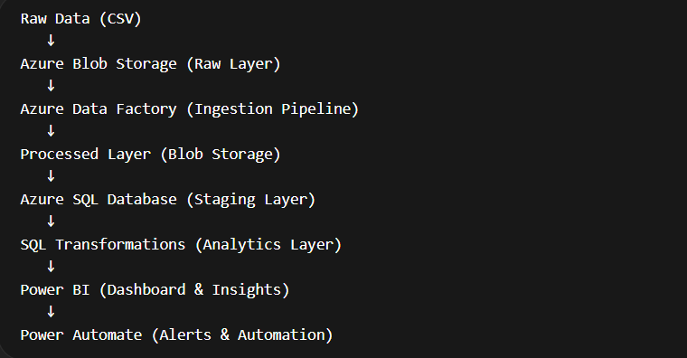
Step 1 — Data Understanding & Profiling
The project began with a structured loan dataset containing 10,000 records and 55 features, including borrower demographics, credit behavior, loan details, and repayment history.
Key Actions:
- Performed data profiling using Python
- Identified:
  - Missing values
  - Data types
  - Target variable (loan_status)
- Observed high class imbalance (majority loans were “Current”)
Key Insight:
Null values in behavioral columns (e.g., delinquency history) represented absence of events, not missing data.
Step 2 — Cloud Data Ingestion (Azure)
Azure Blob Storage (Raw Layer)
- Created storage account and container (raw-data)
- Uploaded raw dataset without modification
- Followed principle: Raw data must remain immutable
Azure Data Factory (ADF)
Built ingestion pipelines to simulate enterprise ETL workflows:
🔹 Pipeline 1:
Raw Layer → Processed Layer
- Copied raw CSV into a structured processed zone
- Established layered architecture
🔹 Pipeline 2:
Processed Layer → Azure SQL
- Loaded data into relational database
- Implemented schema mapping
- Resolved type conversion errors (NA → NULL)
Step 3 — Data Storage (Azure SQL Database)
- Created cloud-based SQL database using:
  - Serverless compute (cost optimized)
  - Auto-pause functionality
- Designed staging table (loans_staging) to store raw structured data
Design Principle:
Separated:
- Raw storage (Blob)
- Structured storage (SQL)
Step 4 — Data Transformation (SQL Layer)
Converted raw data into analytics-ready dataset:
Key Transformations
1️⃣ Target Variable Creation
- default_flag
- Defined default using:
  - Charged Off
  - Late payments
2️⃣ Risk Segmentation
risk_category
- Based on:
  - Debt-to-income ratio
  - Credit behavior
3️⃣ Missing Value Handling
Applied business-aware imputation:
COALESCE(months_since_last_delinq, 999)
- Created flags:
no_delinq_flag
Captured both:
- Value
- Behavioral meaning
4️⃣ Feature Engineering
Created key indicators:
- Credit utilization ratio
- Payment ratio
- Delinquency indicators
Step 5 — Visualization Layer (Power BI)
1. Executive Overview
- Total Loans
- Total Loan Amount
- Default Rate
- Average Interest Rate
- Provides high-level business summary

2. Risk Segmentation Dashboard
- Default rate by credit grade
- Default rate by risk category
- Debt-to-income (DTI) bucket analysis
- Identifies high-risk borrower segments
3. Loan Performance & Risk Insights
- Default rate by loan amount range
- Payment ratio vs default behavior
- Loan term (36 vs 60 months) analysis
- Paid vs outstanding balance
- Evaluates financial behavior and loan performance
4. Recovery & Behavior Analysis
- Payment distribution analysis
- Repayment trends across segments
- Behavioral insights into default patterns
Key Visualization Insight
- Lower credit grades (F, G) → higher default rates
- Longer-term loans → increased risk
- Payment behavior strongly correlates with default
- Risk segmentation reveals scope for improvement

Color Palette:
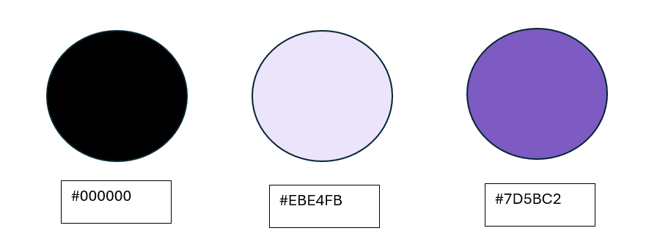
Key Learnings
Data Engineering
- Built ETL pipelines using Azure Data Factory
- Handled schema mismatches and null values
- Designed layered data architecture
SQL & Analytics
- Feature engineering using SQL
- Business-driven data transformations
- Risk modelling logic
Cloud Architecture
- Blob Storage (Data Lake)
- Azure SQL (Warehouse)
- ADF (Orchestration)
Problem Solving
- Fixed permission errors (IAM)
- Resolved type conversion issues
- Debugged pipeline failures

